Name:
Monitor | Keyboard | CPU tower | Webcam
Mouse | Printer | DVD drive | Flash drive
Speakers | Tablet | Headphones | Video Cam
Camera | Blank CDs | Microphone | E-Reader
Copy and Paste Technology
 |  | 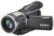
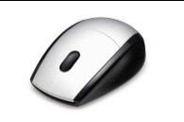 |  | 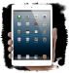
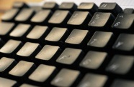 |  | 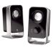
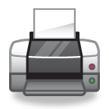 |  | 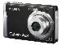
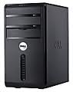 |  | 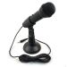
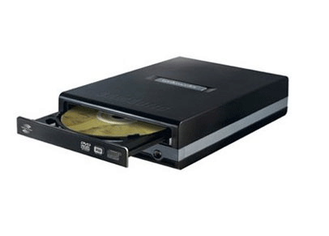 |  | 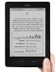
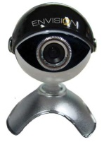
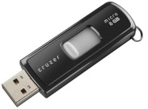 |  | 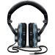
*it the part is an Input device, change the font to BLUE, output=RED, storage device=Green

